Dimensions of drawing are cm. Create each shape in the new part.

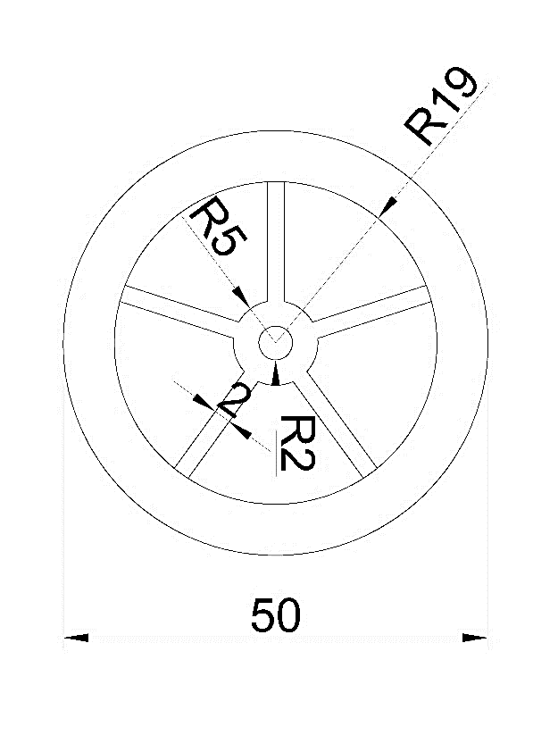

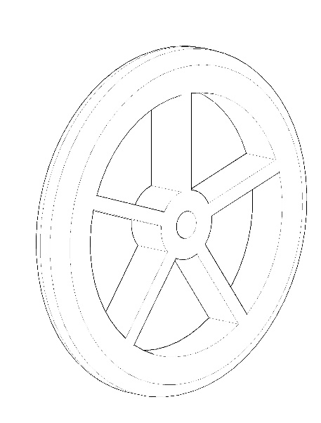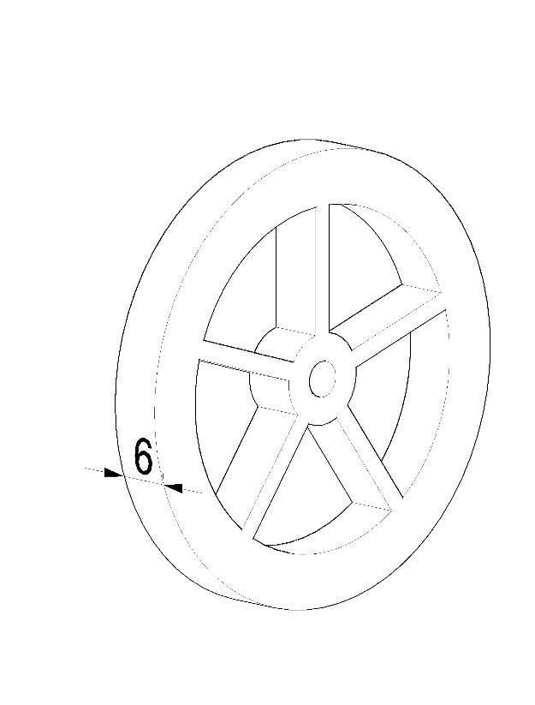

Apply 2cm Radius to the outer edges of the cylinder

Create the drawing on the right plane

Give the extrude value 6 cm. Middle part is hole

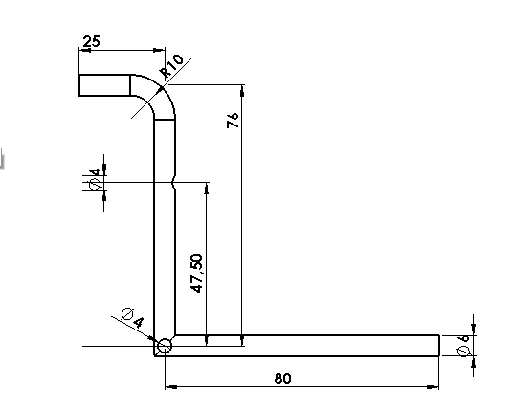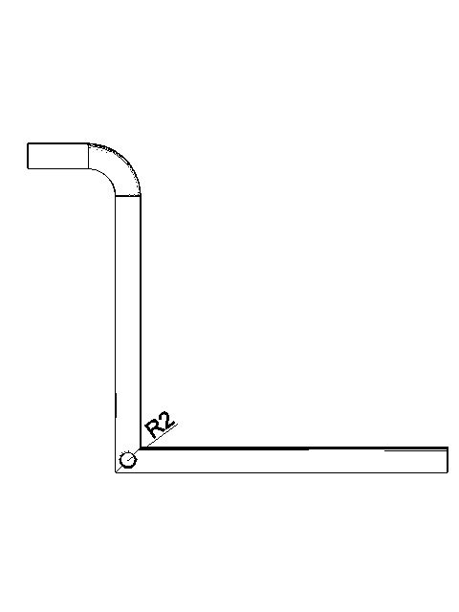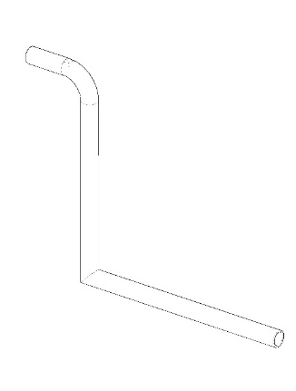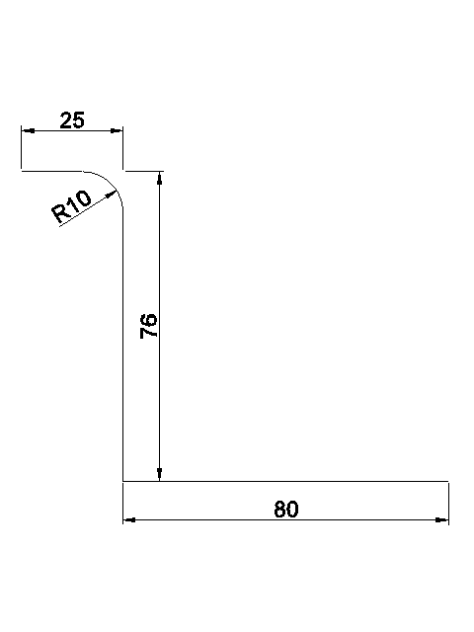

Create a circular hole wth a Radius of 2cm and a depth of 4cm. The distance from the enter of the following circle is 47.5 cm.

Use swept command. The circular profile Radius is 3 cm. Thin feature. The thickness is 1 and its direction should be inward

Create the drawing on the right plane

Create a circular hole with a Radius of 2cm

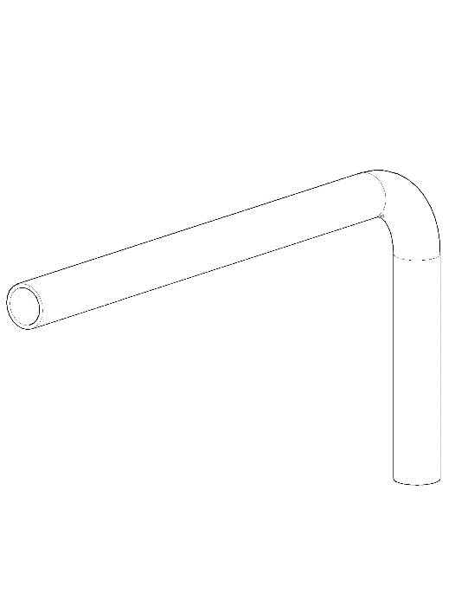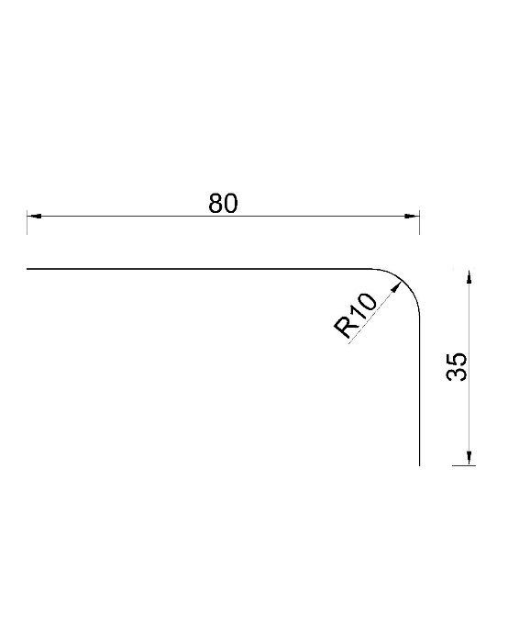

Create the profile on the right plane

Use swept command. The circular profile Radius is 3cm. Thin feature. The thickness is 1 and its direction should be inward

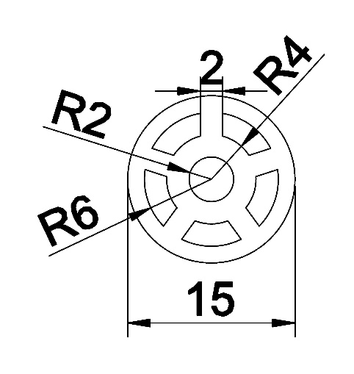

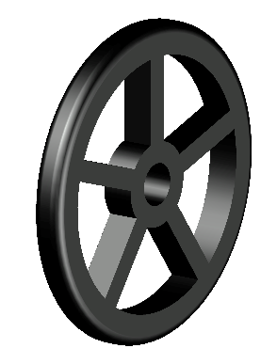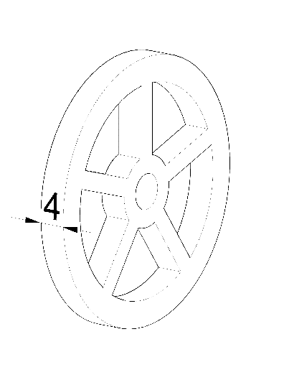

Create the drawing on the right plane

The extrude height is 4cm. There is a hole in the middle

Apply 1 cm Radius to the outer edges of the cylinder.

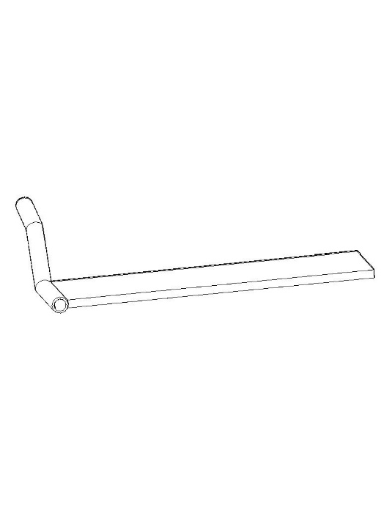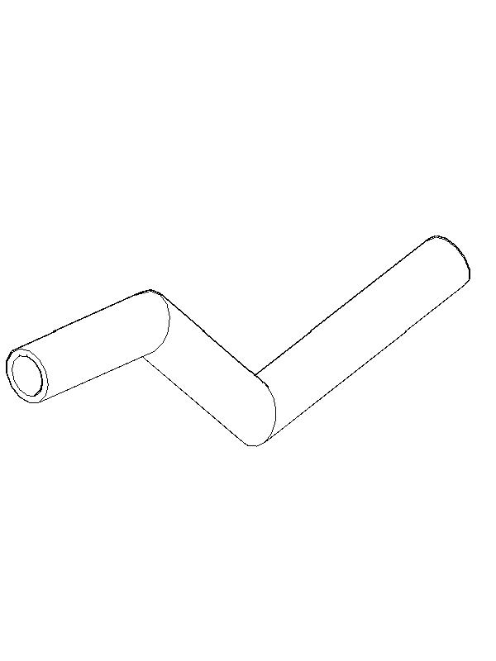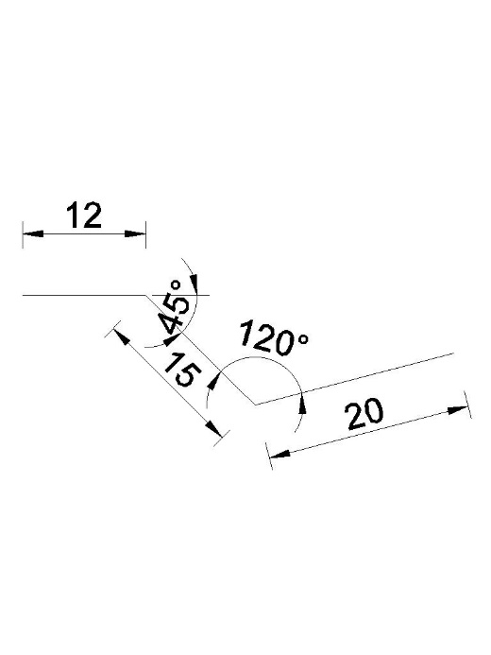

Redraw the 20 cm long line on the right plane. The extrude height is 76 cm. Thin feature thickness 2cm-use midplane

Use swept command. The circular profile Radius is 3cm. Thin feature. The thickness is 1 and its direction should be inward

Create the profile on the right plane

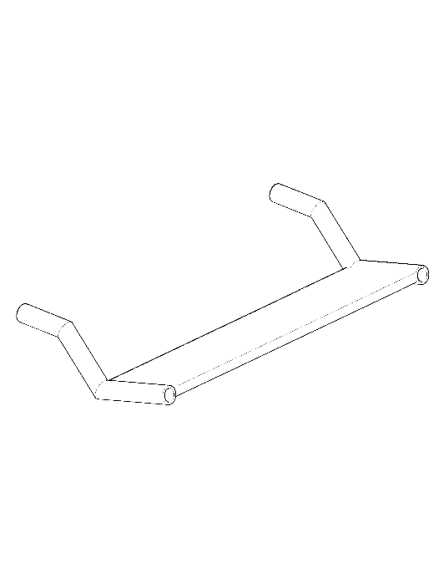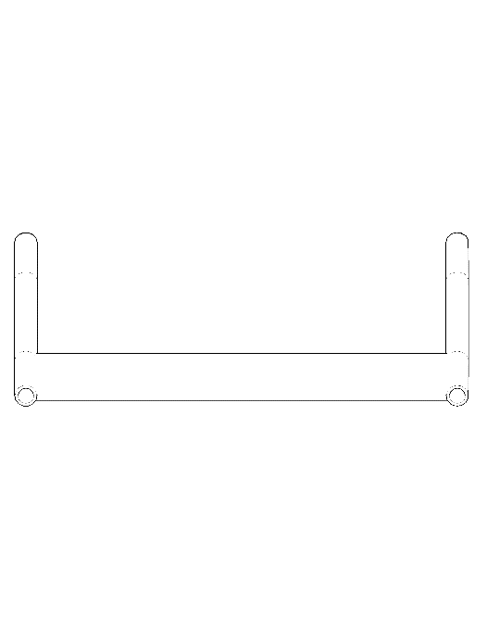

Mirror the profile to the right side of the foot support. The inside of the cylinders are empty

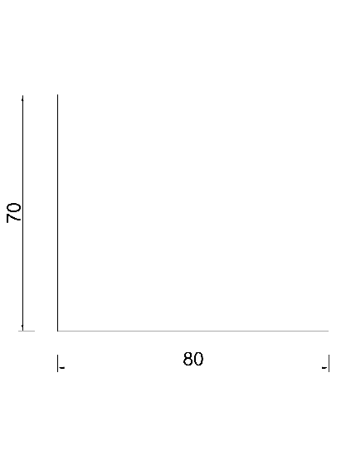

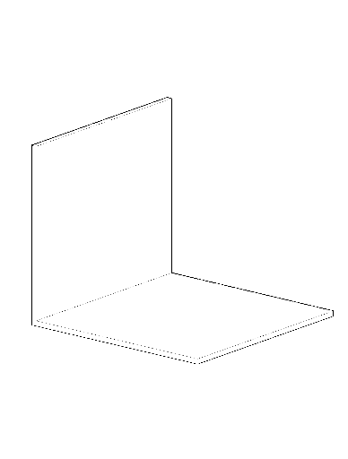

Give 80 cm for extrude height, give 2cm thickness with using midplane

Create the draing on the right plane

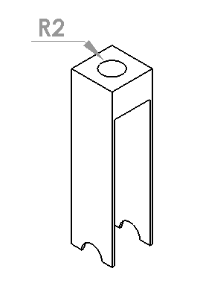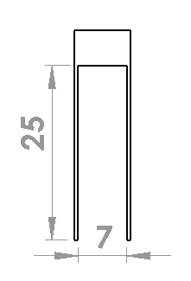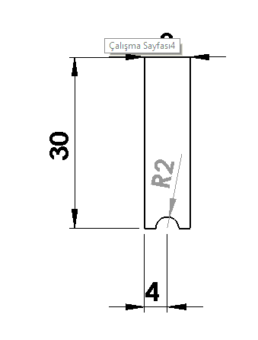

Create the drawing on the right plane. Give extrude. Extrude value is 8 cm.

Create a hole on the top surface with a Radius of 2 cm and a depth of 4 cm.

Take sketch command on the left side and make a rectangular cut

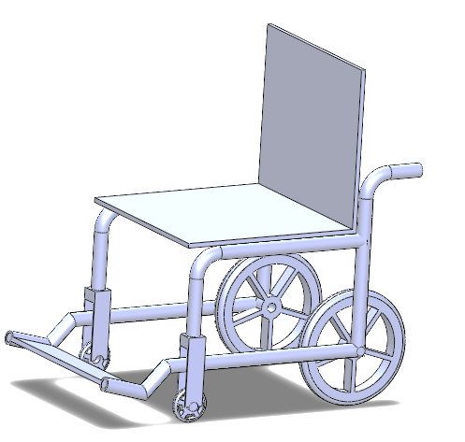

For connection element, crate a cylinder with a Radius of 2 cm and a height of 4 cm. Save this part with the name part 8.

Open a new assembly. Combine your parts like on the Picture.

The wheels must be conneted eachother and should move in the same direction.

The distance of the small Wheel to the side surface of part 7 is 2cm.

Close the cylinder holes with part 8 by using the mates command.